Compound Semiconductor Device Fabrication
In this section we will discuss the methods how we can prepare a compound semiconductor device. While we will concentrate on LEDs, the same broad principles apply to other devices, including Laser Diodes, Photodiodes, Solar Cells, High Speed Transistors etc. where they are based on III-V materials.
In general all semiconductor devices (including those based on Si) can be characterised as a thin structure that is prepared on the surface of a crystal substrate. In the case of Si most of the device can be made by diffusing impurities in by heating the sample in an atmosphere containing the impurity; or firing a beam of the impurity ions on the surface, which incorporates the impurity but damages the sample surface needing an anneal to restore the crystal quality after.
Such processes tend not to work for III-V materials because at elevated temperatures the material does not melt but breaks down. For example in the case of GaAs the As is released, first giving a high density of As vacancies which would compromise the semiconductor quality and ultimately lead to the GaAs crystal turning into a pool of Ga on the wafer holder! It is possible to heat the sample in an As containing atmosphere to overcome this or by protecting the surface to stop the As desorption process.
While these methods can work to change the majority carrier of a semiconductor in a particular area, giving us a homojunction, we have already seen that in the most efficient LEDs (and to make a laser diode work at all at room temperature) we make double heterostructures and / or quantum wells. To make such structures we need to consider methods to prepare thin crystal layers on top of the crystal substrate. This process is called epitaxy.

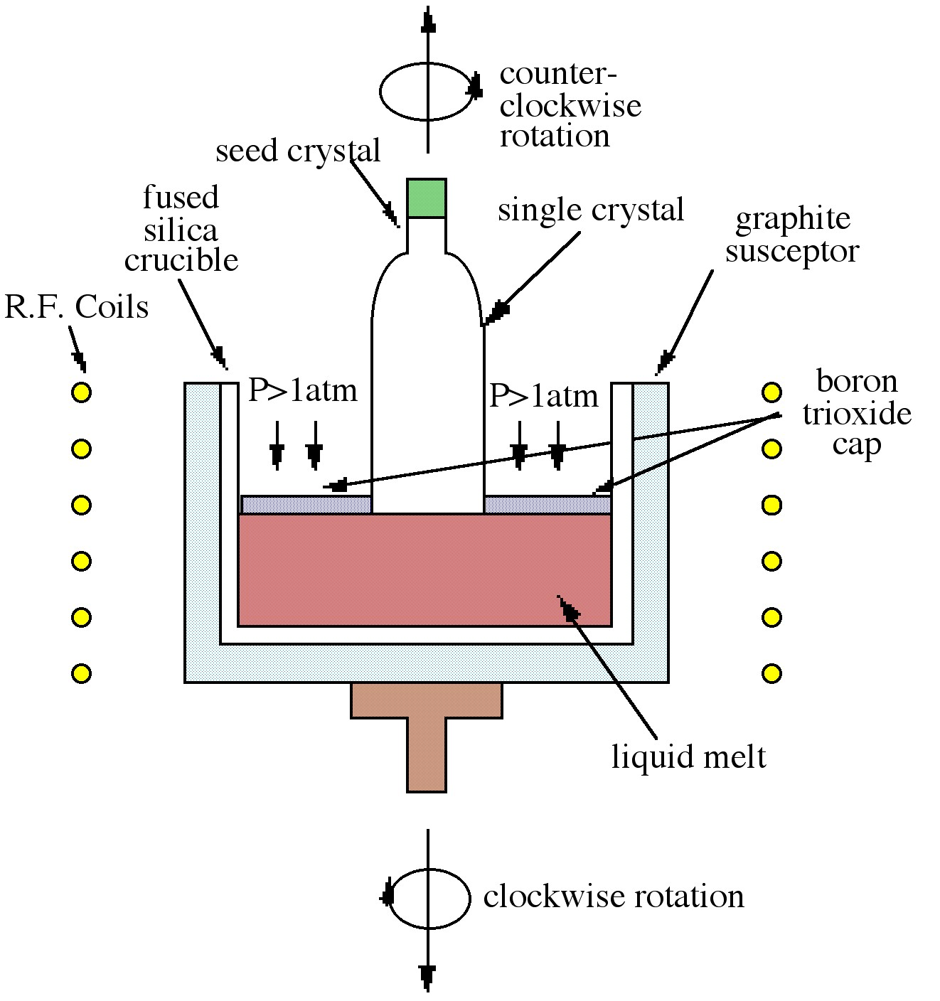
Substrate Manufacture
There are two commonly used ways to get single crystal materials are the Czochralski method and vertical gradient freeze.
In the Czochralski (CZ) method purified lumps of GaAs are melted in a furnace, with a layer of Boron Oxide on the surface. This layer prevents the As escaping when the GaAs is melting, maintaining a congruent melt (same amount of As and Ga). A seed crystal is placed into the melt and slowly pulled upwards. As it does so GaAs solidifies on the base of the seed, allowing it to grow. By controlling the rate the crystal is pulled from the melt, the temperatures in the reactor and the rotation of crystal, the diameter of the crystal can be controlled.
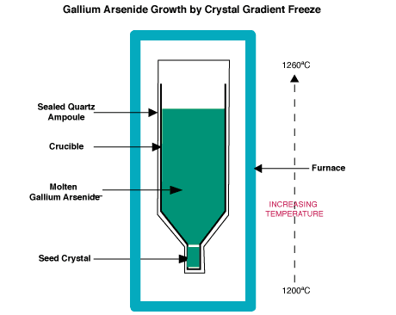
In vertical gradient freeze (VGF) the bulk GaAs is melted on top of a seed crystal in a vertical container in a sealed environment. There is a temperature gradient from the seed at the bottom (cooler), into the melt above. The melt is very slowly cooled making the crystal.
The crystal ingots (or boules) can be 10s cm in length. There will usually be some residual defects in the material, in the form of dislocations that run through much of the length of the ingot. In general, for GaAs VGF material is better, with less defects with in it.
The diameters depend on the difficulty in making the crystal. For large area manufacturing (like LEDs or Solar cells) bigger diameters are better. Typical largest diameters sizes are: 12” for Si (with demonstrations of 18”), 6” for GaAs and 4” for InP. Sapphire can be produced in sizes up to 6” or 8”. SiC can be made in diameters up to 4”.
Once grown the ingot is cut into slices which are polished till they are close to atomically smooth. These single crystal “wafers” are then used for the epitaxial growth of the devices. By placing a fixed level of impurities in the melt the ingot can be doped to be either p-type, n-type, or be made “semi-insulating.

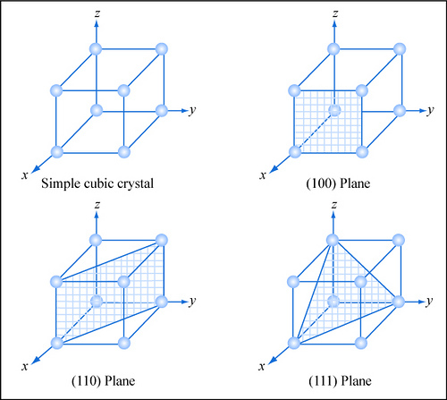
Epitaxy
Epitaxy is the process of growing singly crystal layers on a single crystal substrate. A crystal is a regular array of atoms, and it is not isotropic. This means that the surface of the crystal can have a different behaviour depending on the angle the normal wafer surface makes to direction of the edges of the unit cell. These directions in the crystal can be identified by so-called “Miller Indices”.
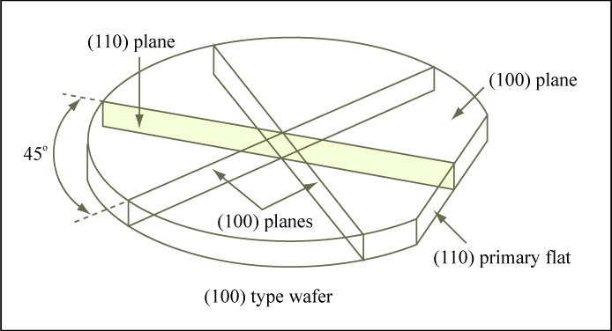
In the cubic lattice we can see some common planes, in the figure. Remember GaAs is a Face Centred Cubic unit cell and there are two interpenetrating lattices for the Ga and As atoms. These are separated by a distance/direction given by moving a ¼ of the unit cell in each of the x,y,z directions.
GaAs and InP wafers are most usually produced with a surface that is a (100) plane. A flat on one side of the wafer lets us know the crystal directions in the plane of the material. This is important as the wafer will normally preferentially break in certain directions given by what is the easiest line to break bonds along, along with the number of bonds that need to be broken to break the wafer. When cutting the wafer into chips for use these directions are important. They are particularly crucial for lasers where the planes that the wafer breaks along form the mirrors that allow light to bound back and forth in the semiconcductor laser cavity. For a (100) substrate the easiest planes for the wafer to break along are the (110) planes.
There are many forms of semiconductor Epitaxy. Here we shall briefly describe three:
Liquid Phase Epitaxy (LPE)
Molecular Beam Epitaxy (MBE)
Metalorganic Vapour Phase Epitaxy (MOVPE)

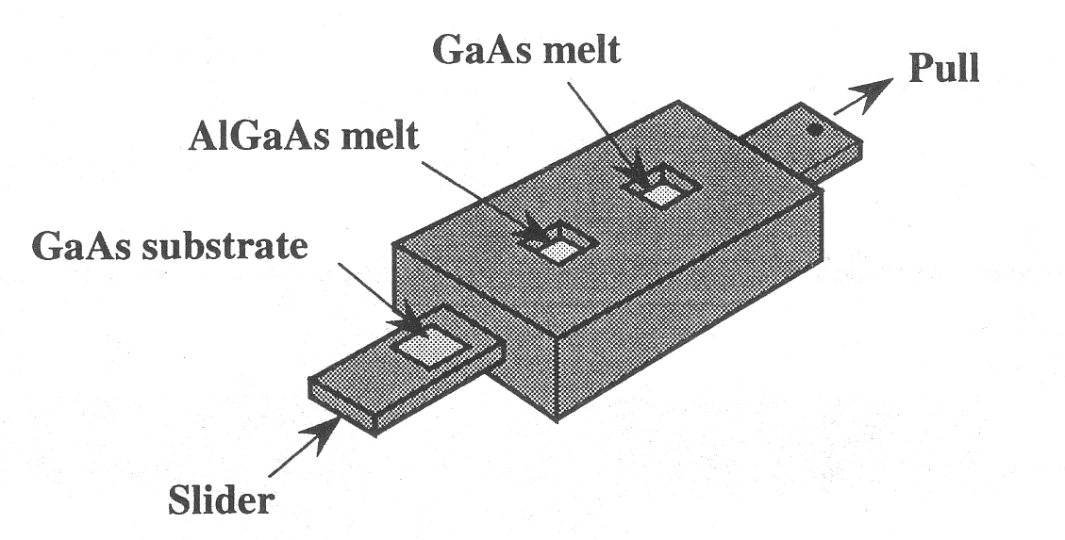
Liquid Phase Epitaxy
LPE is the first epitaxial technique that was used in the fabrication of compound semiconductor devices. It involves a substrate of material being placed on a slider which can be passed over a melt of the material to be grown. By moving the slider from one melt to another a layer of GaAs then AlGaAs can be grown for example. One can also start with melts of different concentrations of dopant to allow junctions to be grown. The technique has a number of limitations. The growth rates, at 0.1-1 µm.min⁻¹ are quite fast and there is a fixed time to slide the substrate from one melt to the other. Thus while double heterojunctions can be made, the atomic resolution and abruptness needed for quantum wells is generally beyond the limits of the method. Its major advantage is that it is relatively cheap making it very cost effective. Indicator type LEDs can still be made by this method for example.

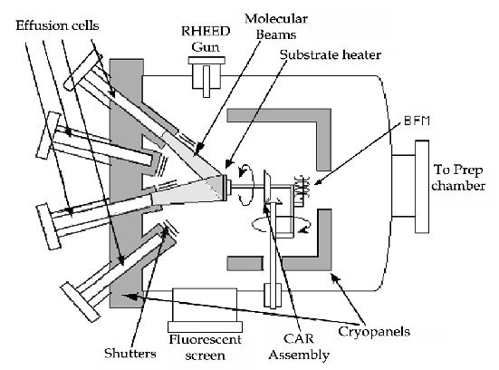
Molecular Beam Epitaxy
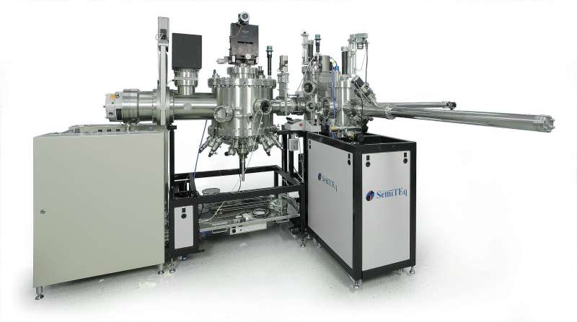
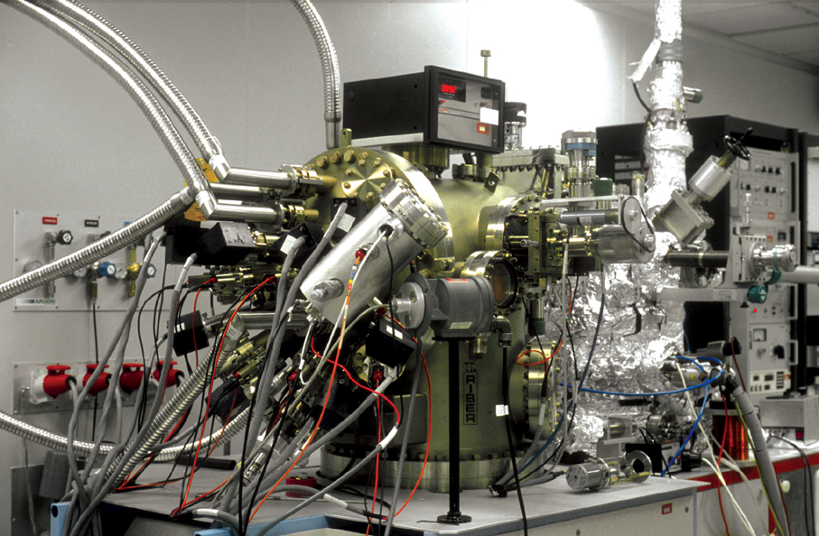
Gas phase techniques have much better potential for atomic scale control. The two most common are MBE and MOVPE.
In MBE the substrate is placed in a high vacuum chamber and heated. Pure sources of the elements wanted are placed in Knudsen Cells (Effusion Cells) which are heated until a small amount of the material is vapourised from the surface. Due to the low pressure in the chamber these atoms can travel in a beam (without colliding with another atom) to the substrate where the atom can react on the surface to be incorporated in the material. The “beams” can be switched “off” and “on” by the means of shutters placed in front of the cell. Thus by opening the Ga and As cells we can grow GaAs. Opening the shutter to the Al cell would allow growth of AlGaAs. The composition of the AlGaAs would be determined by the relative fluxes (amount arriving per unit time) on the substrate surface, which in turn can be controlled by the temperature of the Al and Ga source cells.
As the shutters can be turned off and on almost instantaneously we can literally control the growth on the atomic scale, allowing the growth of quantum wells. Doping can be achieved by having cells containing the dopant impurities, which will have a very small flux, relative to the main elements of the crystal.
The high vacuum is maintained throughout as the chamber contains liquid nitrogen cooled “shrouds” to freeze out any material that is in the chamber that does not his the substrate (or its holder). This high vacuum allows use to use electrons to probe the surface as it is grown giving an in-situ monitor of how the growth is developing. The wafer substrate is rotated during growth to get a uniform layer, as the cells are angled to the substrate so the growth rate on the far side will be slightly less than the near side. An issue is that the chamber can take up to two weeks to be brought back into service if it needs to be opened, for example to fill a cell with more material. Thus wafers are taken in and out of the reactor using a load lock, which is pumped down and the wafer mechanically transferred into the reactor.
Originally MBE was regarded as mainly a scientist’s tool as it allowed precise growth control, but was expensive to purchase and the potential for long periods of downtime was a problem. The system also was viewed as being difficult to scale up to larger size. However methods to allow cell replenishment without opening the reactor and designs that can allow multiple wafers (up to 3x8” for example) mean that the technique can be used industrially. It is particularly popular for electronic devices (high speed transistors) rather than optoelectronic devices. The generally lower growth temperature compared to MOVPE (described below) should in principle give more abrupt interfaces, but can lead to a higher density of point defects that can affect the optical emission.
The growth rate of material is quite slow, of the order of 1 µm.hr⁻¹, meaning that a device can take a few hours to grow, with additional time to transfer the wafer in and out of the reactor chamber.

Metalorganic Vapour Phase Epitaxy
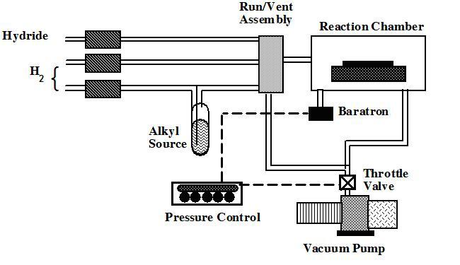
The main problem with trying to grow GaAs or any other compound semiconductor from the gas phase is that many of the elements have very high vapourisation points. For example in MBE the cell temeratures are often around 1000ºC. This means that to carry the element in gas flow requires a very special arrangement which can be used to make thick layers (HVPE) but is not practical for atomic level control. However, metalorganics such as trimethylgallium (CH₃)₃Ga are liquids at room temperature, with a fairly high vapour pressure. This means that if be bubble a small amount of hydrogen through the liquid some of the (CH₃)₃Ga will be picked up and can be transported to the reactor. We can obtain As using AsH₃ (arsine) which is a gas and can be stored in a stainless steel bottle. Both of these flows can be transported in to the reactor using an arrangement of pipes and valves. We can get metalorganic , or hydride sources for all the requiste III-V elements and dopants.
In the reactor the gas passes over a heated substrate where the compounds react to form the semiconductor. We can control the growth rate and composition of the material using precise flow meters and controlling the temperature of the metalorganic sources. Atomic level control is achieved as the gases can be switched on and off with valves that switch in a fraction of a second.
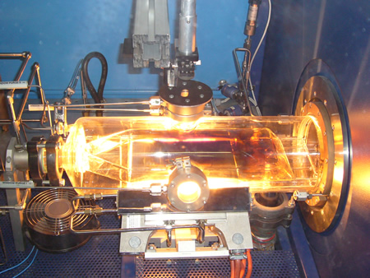
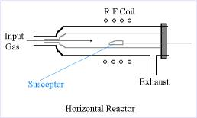
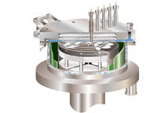
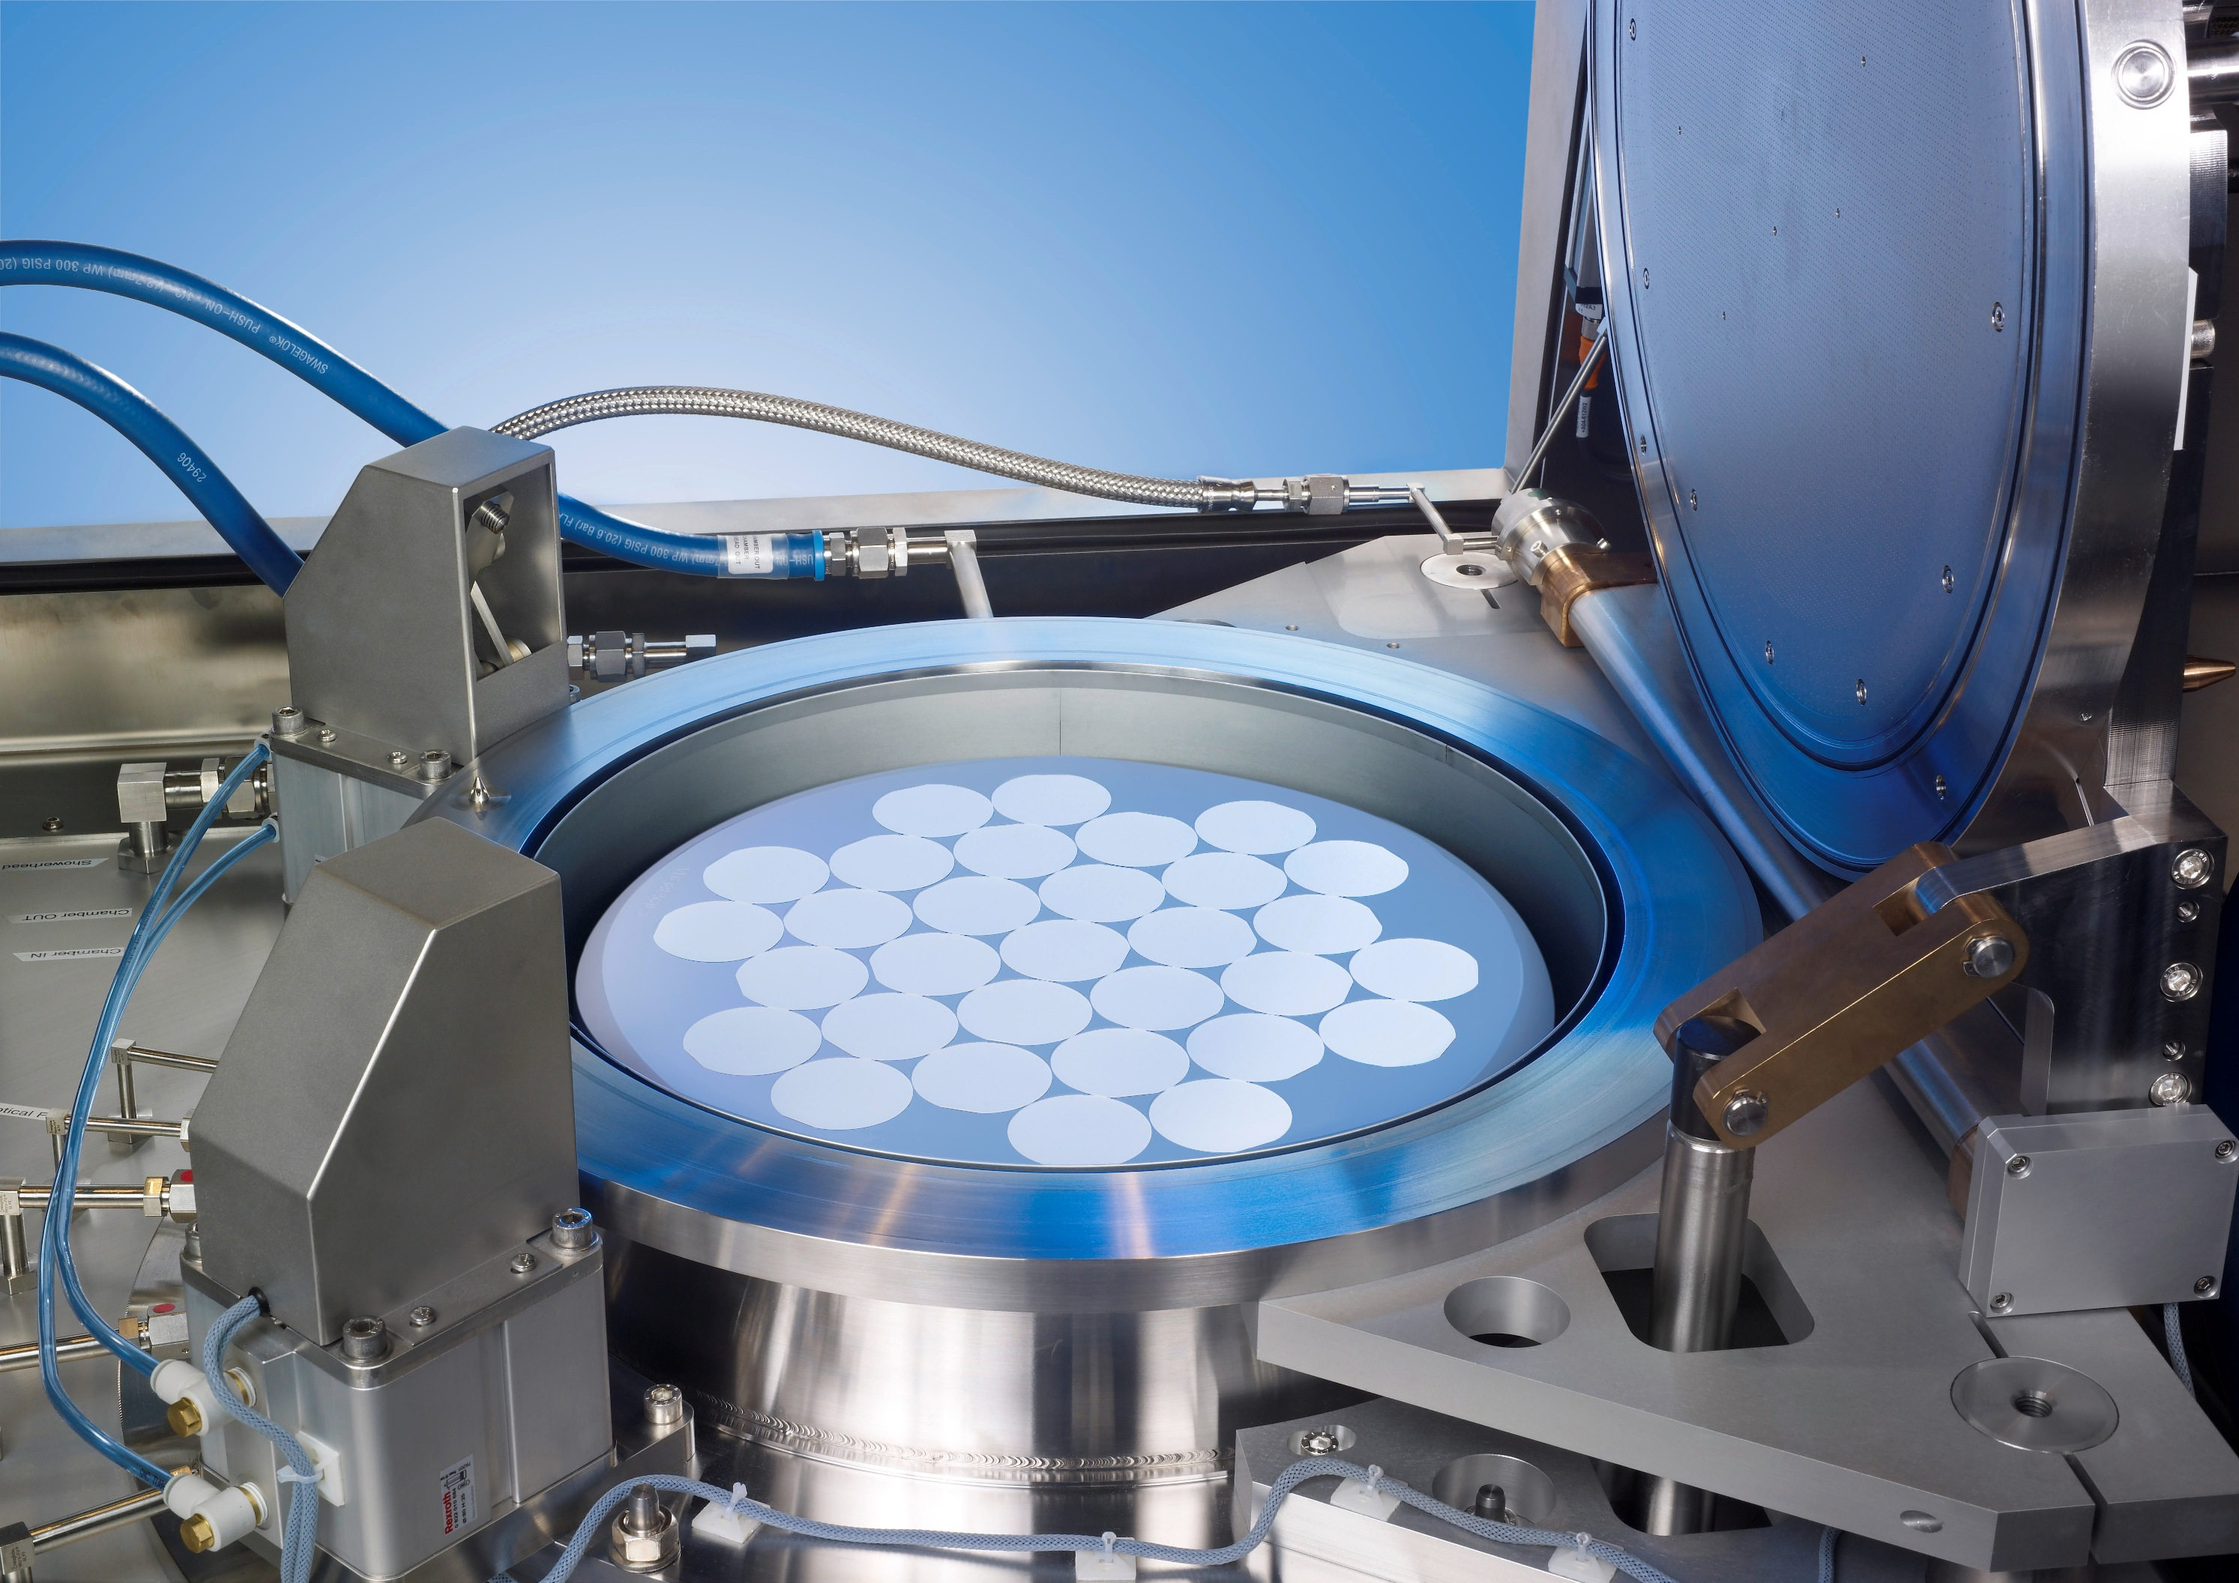
There are two reactor geometries, either the gas is injected horizontally or vertically. In both ensuring that the layers grown are uniform across the wafer is critical. This can be achieved by tilting the wafer in a horizontal reactor (to allow for reactant depletion along the wafer) and/or spinning the wafers to compensate for this effect. In the vertical design uniform injection of the reactants and spinning the susceptor (the heated block on which the wafers sit) is used. One way to achieve that uniformity is to inject the gas in a shower all over the wafer area.
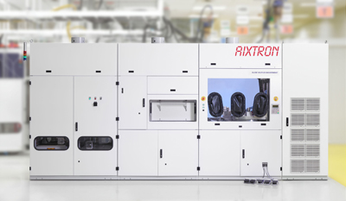
MOVPE has the advantage of being relatively easily scalable to larger areas. Further as there is no high vacuum issue the reactor does not need to have special time consuming pump down processes. However, there are downsides. While initially the reactor purchase price was much cheaper than MBE, modern systems with high levels of control are much more expensive. Further the installation costs are high, especially as the hydrides, such as arsine are very toxic, meaning that great care is needed to ensure there is no accidental exposure of the material to the outside, and to ensure that the exhausted materials are scrubbed of their toxic content.
For both MOVPE and MBE it is worth emphasizing that purity is critical. Dopant levels can be as low as parts per million, so the purity of the gases and source materials needs to be measure in the parts per billion level!

